**Unit 3 – Review**

**position vs time**

0

1

2

3

4

5

6

7

8

9

10

0

10

20

30

40

50

**time (s)**

**position (m)**

1. Use the graph above to answer the following questions.
   1. Give a written description to describe the motion of this object.
   2. Draw the motion map for the object. Include velocity and acceleration vectors.

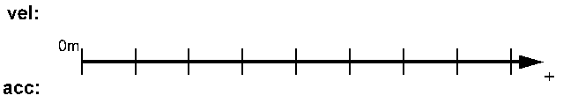

* 1. Determine the instantaneous velocity of the object at *t* = 2 s and explain how you did it.
  2. Assume the initial velocity was 10 m/s, determine the acceleration of the object.
  3. Sketch a corresponding velocity time graph.

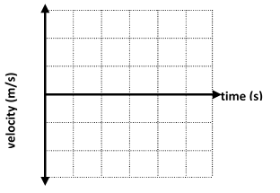

1. A car, initially at rest, accelerates at a constant rate of 4.0 m/s2 for 6 s. How fast will the car be traveling at *t* = 6 s?
2. Use the graph to answer the following questions.
   1. Describe the motion of the object.
   2. Determine the acceleration of the object from the graph. *(Note: velocity reaches the t-axis at t = 7.5 s.)*
   3. Determine the displacement of the object during the time interval *t* = 0 s to *t* = 7.5 s two different ways: graphically and by using the equation 
   4. A fellow student makes the claim that since the acceleration was (+) the object must have been speeding up over this time interval. How would you respond to this claim?
3. Draw a motion map, including both velocity and acceleration vectors for the cart on ramp situation shown below.



**vel:**

**acc:**

0m

+

1. 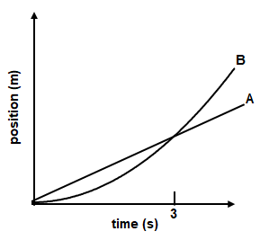Using the graph, compare the following quantities for objects A and B. **Is A > B, A < B, or A = B.**
   1. **Displacement** from 0 to 3 s  ___________ How do you know?
   2. **Displacement** from 0 to 1.5 s ___________ How do you know?
   3. **Average** velocity from 0 to 3 s ___________ How do you know?
   4. **Instantaneous** velocity at 3 s ___________ How do you know?
   5. If the motion of B is uniformly accelerated, at what time will both graphs have exactly the same slope? Explain.
2. For each of the position vs time graphs shown below, draw the corresponding *v* vs*t*, *a* vs *t*, and motion map.

**+**

**-**

**velocity**

**+**

**-**

**time**

**time**

**time**

**position**

**acceleration**

**+**

**-**

**velocity**

**+**

**-**

**time**

**time**

**time**

**position**

**acceleration**

**+**

**-**

**velocity**

**+**

**-**

**time**

**time**

**time**

**position**

**acceleration**

**vel:**

**acc:**

0m

+

**vel:**

**acc:**

0m

+

**vel:**

**acc:**

0m

+